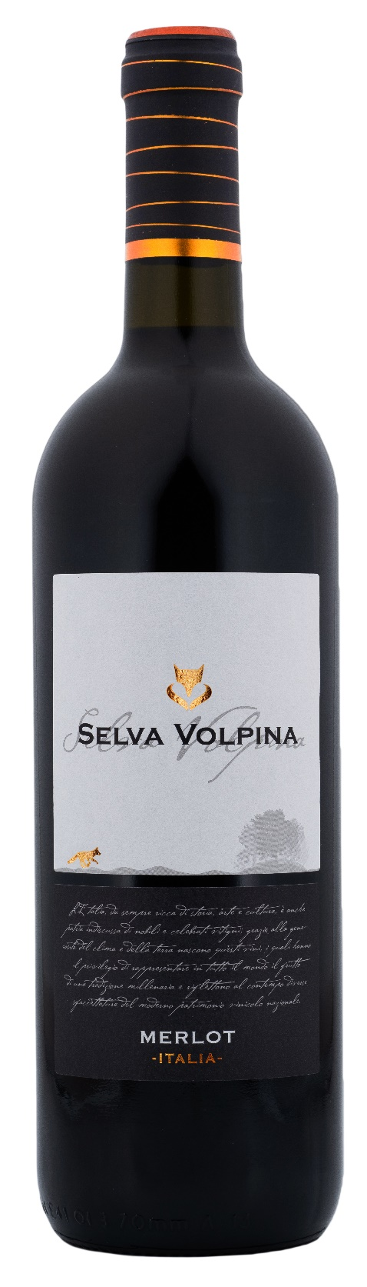
MERLOT ITALIA – SELVA VOLPINA

Grape: Merlot 100%
Alc. Vol.%: 13
Vintage: 2024
Residual sugar g/l: 6,1
Total acidity g/l: 5,3
Production zone: Vineyards in Central Italy
Capacity: 750ml, 1500ml

CHARACTERISTICS

Vinification: In steel tanks at a controlled temperature
Aging: At least 6 months steel tanks
Yield per ha: 16000kg
Colour: Intensive and brilliant red
Bouquet: Fruity and lasting with hints of wildflowers
Flavour: Well-balanced, harmonious, and long-lasting

SERVING SUGGESTIONS

Excellent with pasta, red and grilled meat, cheese.
Serving temperature 18 °C
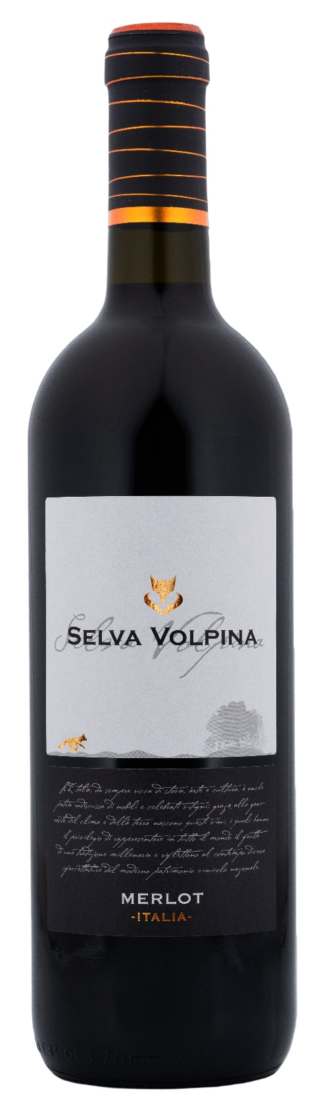
TECHNICAL INFORMATION / PALLETIZING

Size 750ml:
Article Nr. V10001A
GTIN-13 bottle 8017868003502
GTIN-13 carton 8017868002666
Closure Cork/Screwcap
Bottles / carton 6 bottles
Pallet size 80x120cm
Cartons/layer 25
Cartons/pallet 125
Kg/carton 7,2
Kg/pallet 925

Size 1500ml:
Article Nr. V10002B
GTIN-13 bottle 8017868002598
GTIN-13 carton 8017868004592
Closure Screwcap
Bottles / carton 6 bottles
Pallet size 80x120cm
Cartons/layer 14
Cartons/pallet 56
Kg/carton 13,4
Kg/pallet 790

Contains sulphites
GMO Free
Revisione 01. 14.05.2026

